Assignment-3

**Submitted by: Tanmay Vig**

**Roll Number: 19BCS061**

**Batch: 2nd year CSE**

Create a relational database that contains the following tables and insert the following data into these tables.

department:

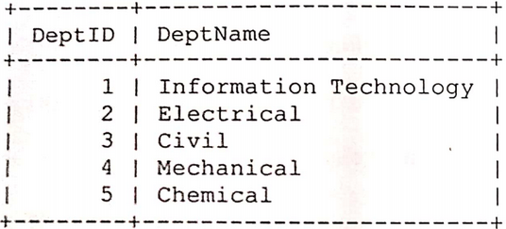

stud_member:

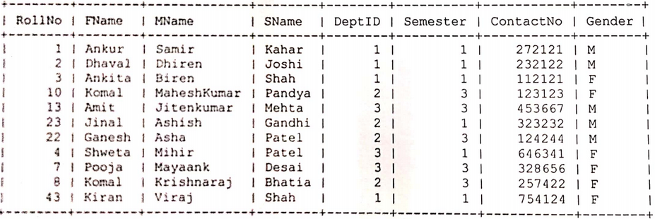

Now, solve the following SQL Queries:

1. Display the names and contact numbers of all student members.

2. Give the names and roll number of all students of Information Technology who are the members.

3. Display names of Departments whose students are members.

4. Display names of Departments for which no student are members.

5. Display names of all Departments.

6. Find the number of students of Electrical Department who are members.

7. Display information of student members whose name begins with the letter A.

8. Display all details of Male members only.

9. Display data of student members who are currently in semester 3.

10. Display data of student female members in alphabetical order.

**Answer:**

**1.**

mysql> SELECT CONCAT(FName,' ',MName,' ',SName) AS Name, ContactNo

-> FROM stud_member;

+--------------------------+-----------+

| Name | ContactNo |

+--------------------------+-----------+

| Ankur Samir Kahar | 272121 |

| Dhaval Dhiren Joshi | 232122 |

| Ankita Biren Shah | 112121 |

| Komal MaheshKumar Pandya | 123123 |

| Amit Jitenkumar Mehta | 453667 |

| Jinal Ashish Gandhi | 323232 |

| Ganesh Asha Patel | 124244 |

| Shweta Mihir Patel | 646341 |

| Pooja Mayaank Desai | 328656 |

| Komal Krishnaraj Bhatia | 257422 |

| Kiran Viraj Shah | 754124 |

+--------------------------+-----------+

**2.**

mysql> SELECT CONCAT(FName,' ',MName,' ',SName) AS Name, RollNo

-> FROM stud_member

-> WHERE DeptID = 1;

+---------------------+--------+

| Name | RollNo |

+---------------------+--------+

| Ankur Samir Kahar | 1 |

| Dhaval Dhiren Joshi | 2 |

| Ankita Biren Shah | 3 |

| Kiran Viraj Shah | 43 |

+---------------------+--------+

**3.**

mysql> SELECT DISTINCT D.DeptName

-> FROM department AS D, stud_member AS S

-> WHERE D.DeptID = S.DeptID

-> ORDER BY D.DeptID;

+------------------------+

| DeptName |

+------------------------+

| Information Technology |

| Electrical |

| Civil |

+------------------------+

**4.**

mysql> SELECT DeptName

-> FROM department

-> WHERE DeptID NOT IN (SELECT DeptID FROM stud_member);

+------------+

| DeptName |

+------------+

| Mechanical |

| Chemical |

+------------+

**5.**

mysql> SELECT DeptName FROM department;

+------------------------+

| DeptName |

+------------------------+

| Information Technology |

| Electrical |

| Civil |

| Mechanical |

| Chemical |

+------------------------+

**6.**

mysql> SELECT COUNT(*)

-> FROM stud_member

-> WHERE DeptID = 2;

+----------+

| COUNT(*) |

+----------+

| 4 |

+----------+

**7.**

mysql> SELECT * FROM stud_member

-> WHERE FName LIKE 'A%';

+--------+--------+------------+-------+--------+----------+-----------+--------+

| RollNo | FName | MName | SName | DeptID | Semester | ContactNo | Gender |

+--------+--------+------------+-------+--------+----------+-----------+--------+

| 1 | Ankur | Samir | Kahar | 1 | 1 | 272121 | M |

| 3 | Ankita | Biren | Shah | 1 | 1 | 112121 | F |

| 13 | Amit | Jitenkumar | Mehta | 3 | 3 | 453667 | M |

+--------+--------+------------+-------+--------+----------+-----------+--------+

**8.**

mysql> SELECT * FROM stud_member

-> WHERE Gender = 'M';

+--------+--------+------------+--------+--------+----------+-----------+--------+

| RollNo | FName | MName | SName | DeptID | Semester | ContactNo | Gender |

+--------+--------+------------+--------+--------+----------+-----------+--------+

| 1 | Ankur | Samir | Kahar | 1 | 1 | 272121 | M |

| 2 | Dhaval | Dhiren | Joshi | 1 | 1 | 232122 | M |

| 13 | Amit | Jitenkumar | Mehta | 3 | 3 | 453667 | M |

| 23 | Jinal | Ashish | Gandhi | 2 | 1 | 323232 | M |

| 22 | Ganesh | Asha | Patel | 2 | 3 | 124244 | M |

+--------+--------+------------+--------+--------+----------+-----------+--------+

**9.**

mysql> SELECT * FROM stud_member

-> WHERE Semester = 3;

+--------+--------+-------------+--------+--------+----------+-----------+--------+

| RollNo | FName | MName | SName | DeptID | Semester | ContactNo | Gender |

+--------+--------+-------------+--------+--------+----------+-----------+--------+

| 10 | Komal | MaheshKumar | Pandya | 2 | 3 | 123123 | F |

| 13 | Amit | Jitenkumar | Mehta | 3 | 3 | 453667 | M |

| 22 | Ganesh | Asha | Patel | 2 | 3 | 124244 | M |

| 7 | Pooja | Mayaank | Desai | 3 | 3 | 328656 | F |

| 8 | Komal | Krishnaraj | Bhatia | 2 | 3 | 257422 | F |

+--------+--------+-------------+--------+--------+----------+-----------+--------+

**10.**

mysql> SELECT * FROM stud_member

-> WHERE Gender = 'F'

-> ORDER BY FName;

+--------+--------+-------------+--------+--------+----------+-----------+--------+

| RollNo | FName | MName | SName | DeptID | Semester | ContactNo | Gender |

+--------+--------+-------------+--------+--------+----------+-----------+--------+

| 3 | Ankita | Biren | Shah | 1 | 1 | 112121 | F |

| 43 | Kiran | Viraj | Shah | 1 | 1 | 754124 | F |

| 10 | Komal | MaheshKumar | Pandya | 2 | 3 | 123123 | F |

| 8 | Komal | Krishnaraj | Bhatia | 2 | 3 | 257422 | F |

| 7 | Pooja | Mayaank | Desai | 3 | 3 | 328656 | F |

| 4 | Shweta | Mihir | Patel | 3 | 1 | 646341 | F |

+--------+--------+-------------+--------+--------+----------+-----------+--------+